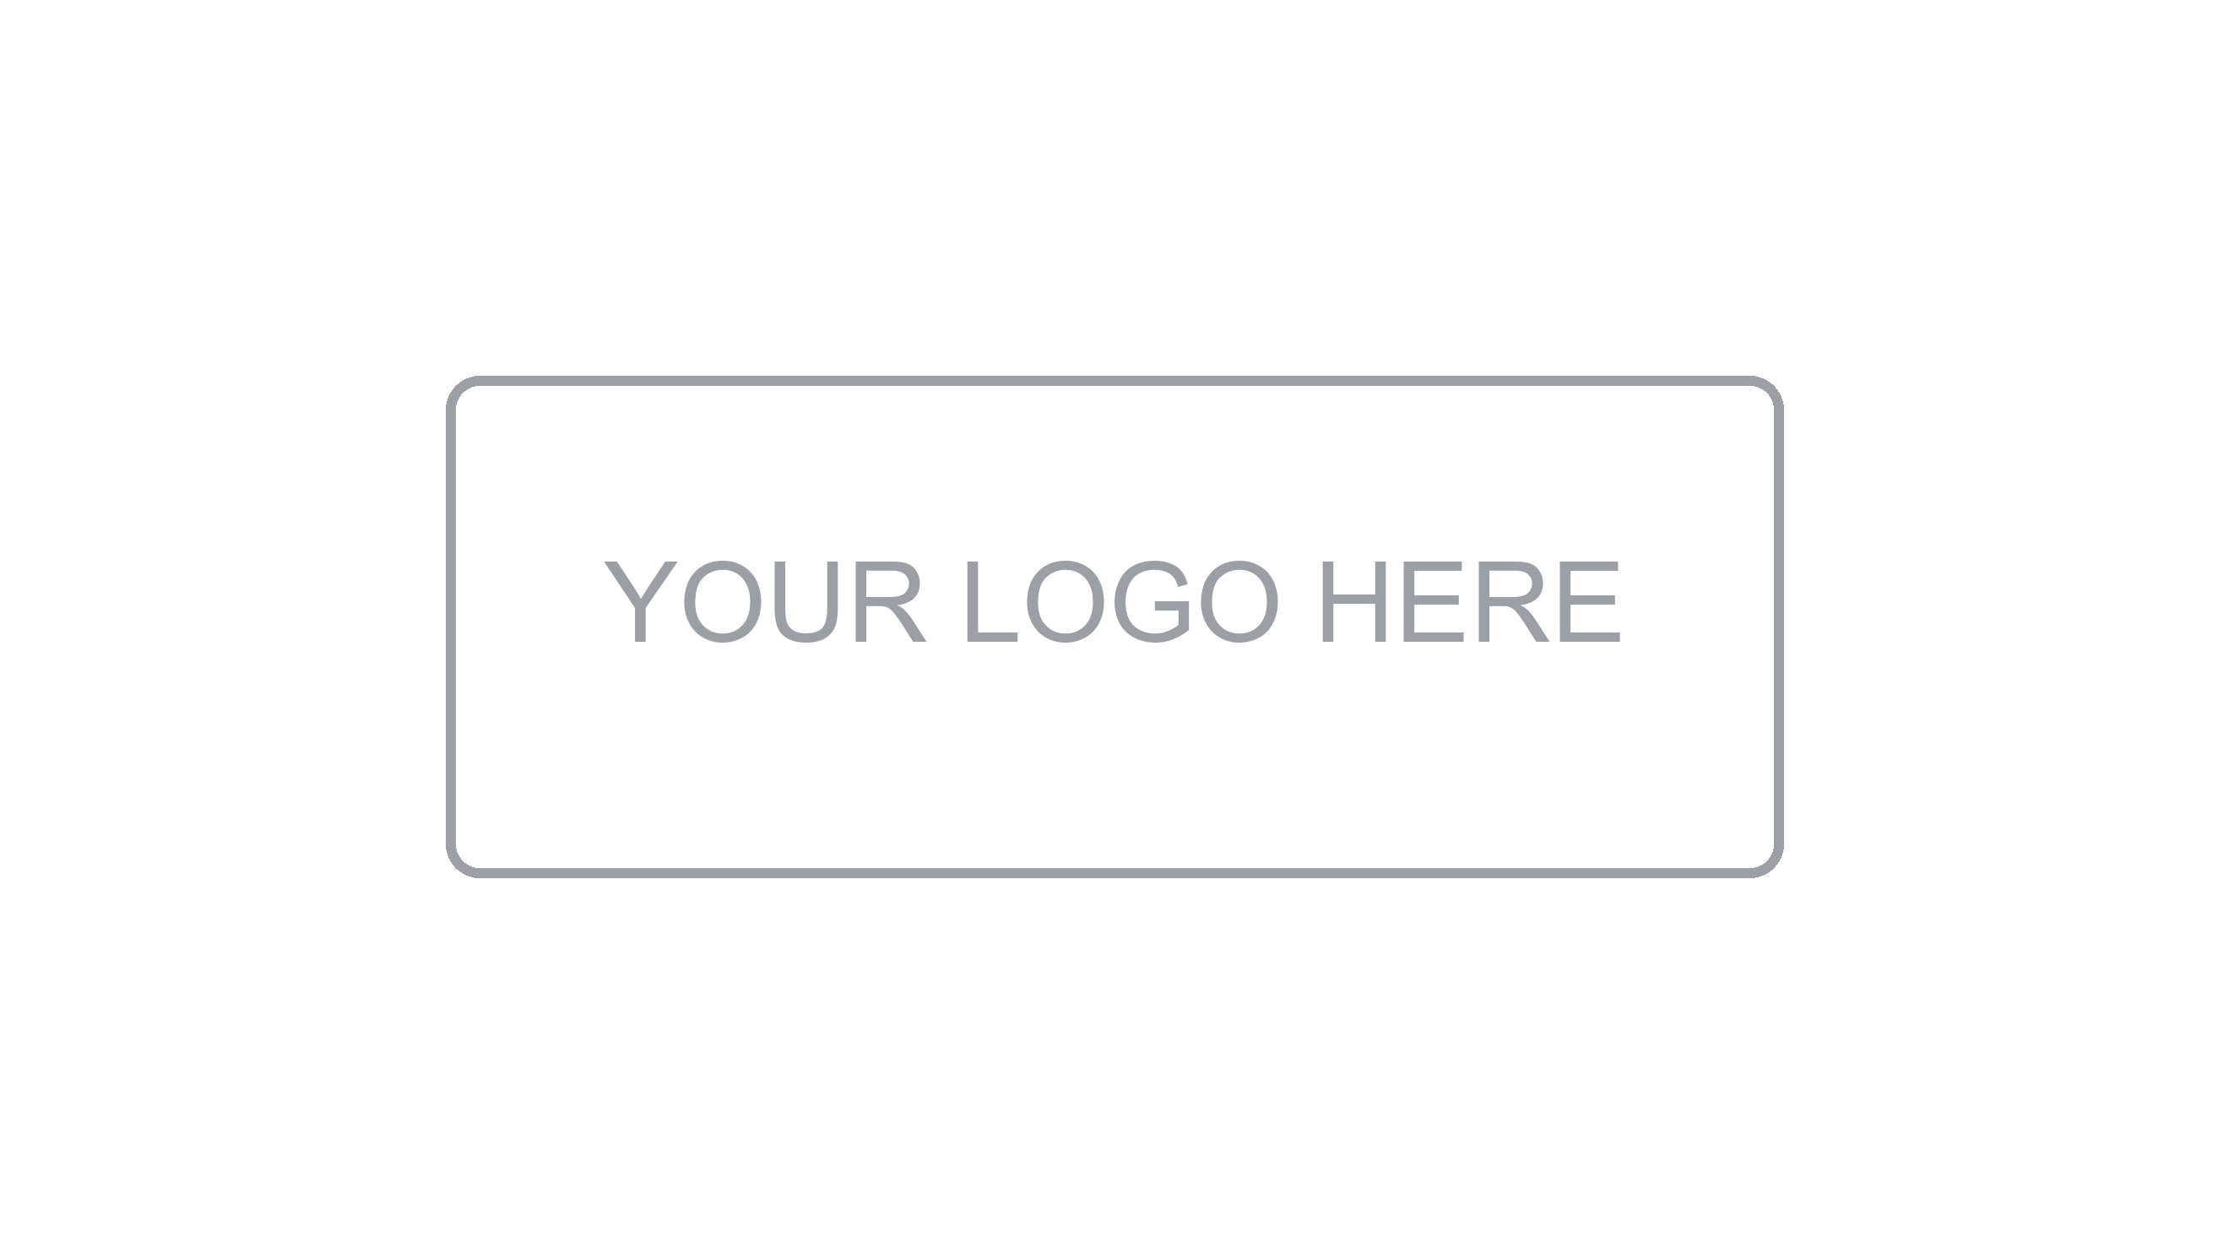

Version Control
and Changes

[Project Name]
Version [X.X] | [Month Year]
Prepared by: [Author Name] | [Team / Area]

About this document
Version Control and Changes

What is this document?
This document is the authoritative record of all changes made to the system over time. It covers the complete version history, user-facing release notes, production incidents and their resolutions, and the deprecation log for features and APIs being phased out. It provides traceability from decisions to releases and supports post-mortem analysis, audits, and stakeholder communication.
Who should read it?
This document is intended for developers, QA engineers, tech leads, project managers, product owners, and any stakeholder who needs to understand what changed between versions, track incidents, or plan deprecation timelines.
What does it contain?
Document Information & Change History | Version control, authorship, and revision log of this document.
Introduction | Purpose, scope, versioning strategy, and definitions.
Version History (Changelog) | Chronological log of all system versions and the changes they introduced.
Release Notes | User-facing summaries of changes per release, organized by version.
Incident Management | Log of production incidents, their root causes, and resolution actions.
Deprecation Log | Record of deprecated features, APIs, and their planned removal timelines.
References & Approvals | Related documents and formal sign-off section.

1. Document Information

Project | [Project Name]
Document Type | Version Control and Changes
Version | [X.X]
Author(s) | [Name(s)]
Reviewer(s) | [Name(s)]
Date | [DD/MM/YYYY]
Status | [Draft / In Review / Approved]

2. Change History

Version | Date | Author | Description of Change
1.0 | [DD/MM/YYYY] | [Name] | Initial version

3. Introduction

3.1 Purpose
[Describe the purpose of this document. Example: This document maintains the complete change record for the [Project Name] system, providing traceability from individual releases to production incidents and deprecated capabilities.]

3.2 Versioning Strategy
This project follows Semantic Versioning (SemVer): MAJOR.MINOR.PATCH

Component | When to Increment | Example
MAJOR | Breaking changes incompatible with previous versions | 1.0.0 → 2.0.0
MINOR | New features that are backward-compatible | 1.0.0 → 1.1.0
PATCH | Backward-compatible bug fixes | 1.0.0 → 1.0.1

💡 Note
Pre-release versions use the suffix format: 1.2.0-alpha.1, 1.2.0-beta.3, 1.2.0-rc.1. Development builds use: 1.2.0-dev.[build-number].

3.3 Change Types
Type | Description | SemVer Impact
Breaking Change | Removes or modifies existing behavior in a way that requires consumer changes | MAJOR
New Feature | Adds new capability without affecting existing functionality | MINOR
Enhancement | Improves existing functionality without breaking changes | MINOR
Bug Fix | Corrects incorrect behavior | PATCH
Security Fix | Addresses a security vulnerability | PATCH
Deprecation | Marks a feature or API for future removal — still functional | MINOR
Documentation | Documentation-only changes | PATCH
Dependency | Updates to third-party libraries or infrastructure components | PATCH / MINOR

3.4 Definitions
Term | Definition
Release | A versioned, deployable package of the system pushed to one or more environments
Changelog | Developer-facing log of all changes introduced in each version
Release Notes | User-facing summary of changes in a release, written in non-technical language
Incident | An unplanned interruption or degradation of service in production
Postmortem | A structured analysis of an incident to identify root cause and prevent recurrence
Deprecation | The process of phasing out a feature or API with advance notice before removal
Hotfix | An emergency patch released outside the normal release cycle to fix a critical issue

4. Version History (Changelog)
[This section is the developer-facing changelog. Log every release with all changes categorized by type. Add new versions at the top (newest first). Keep entries concise and link to tickets where applicable.]

💡 Convention
Entry format: [Type] [Component] — Description ([TICKET-ID]). Example: [Feature] Auth — Added OAuth2 login via Google and GitHub (PROJ-201).

4.1 Version [X.X.X] — [DD/MM/YYYY]
Type | Component | Description | Ticket
Breaking Change | [Component] | [Description of breaking change and migration path] | [TICKET-ID]
New Feature | [Component] | [Description of new feature] | [TICKET-ID]
Enhancement | [Component] | [Description of improvement] | [TICKET-ID]
Bug Fix | [Component] | [Description of fix] | [TICKET-ID]
Security Fix | [Component] | [Description of security fix] | [TICKET-ID]
Dependency | [Component] | [Library/tool updated and version] | [TICKET-ID]

4.2 Version [X.X.X] — [DD/MM/YYYY]
Type | Component | Description | Ticket
New Feature | [Component] | [Description] | [TICKET-ID]
Bug Fix | [Component] | [Description] | [TICKET-ID]
Bug Fix | [Component] | [Description] | [TICKET-ID]

4.3 Version 1.0.0 — [DD/MM/YYYY] (Initial Release)
Type | Component | Description | Ticket
New Feature | [Core Module] | Initial implementation of [core functionality] | [TICKET-ID]
New Feature | [Auth] | User authentication and authorization | [TICKET-ID]
New Feature | [API] | REST API v1 — all endpoints documented | [TICKET-ID]
New Feature | [Database] | Initial schema and migration scripts | [TICKET-ID]

5. Release Notes
[Release notes are user-facing summaries of each release written in plain, non-technical language. They communicate the value delivered, not the implementation details. Add new releases at the top.]

5.1 Release [X.X.X] — [DD/MM/YYYY]
Summary: [One or two sentences describing the overall theme or goal of this release.]

Category | What Changed
New | [User-facing description of new capability. Example: You can now log in using your Google account.]
Improved | [User-facing description of improvement. Example: The dashboard now loads 40% faster.]
Fixed | [User-facing description of fix. Example: Fixed an issue where users were logged out unexpectedly after 10 minutes.]
Deprecated | [User-facing deprecation notice. Example: The legacy /v1/export endpoint is deprecated and will be removed in version 3.0.0.]
Known Issues | [Any known issues in this release. Example: Report export to Excel may be slow for datasets over 10,000 rows — fix planned for v2.1.1.]

5.2 Release [X.X.X] — [DD/MM/YYYY]
Summary: [Brief summary of this release.]

Category | What Changed
New | [Description]
Fixed | [Description]
Fixed | [Description]

5.3 Release 1.0.0 — [DD/MM/YYYY] (Initial Release)
Summary: First public release of [Project Name]. This release introduces the core platform capabilities.

Category | What Changed
New | [Core capability 1 — user-facing description]
New | [Core capability 2 — user-facing description]
New | [Core capability 3 — user-facing description]

6. Incident Management
[This section logs all production incidents. Each entry captures the incident timeline, impact, root cause, and resolution actions. Use this log for postmortems, audits, and process improvement.]

6.1 Incident Severity Levels
Severity | Definition | Response SLA | Examples
P1 — Critical | Complete service outage or data loss affecting all users | Immediate response — 24/7 | Database down, auth service unavailable
P2 — High | Major feature unavailable or severe performance degradation | Response within 1 hour | Payments failing, key API returning 500
P3 — Medium | Partial feature degradation with workaround available | Response within 4 hours | Report exports slow, non-critical API errors
P4 — Low | Minor issue with minimal user impact | Next business day | UI cosmetic bug, non-critical warning in logs

6.2 Incident Log
ID | Date | Severity | Title | Duration | Status
INC-001 | [DD/MM/YYYY] | P1 | [Brief incident title] | [X] hours | Resolved
INC-002 | [DD/MM/YYYY] | P2 | [Brief incident title] | [X] hours | Resolved
INC-003 | [DD/MM/YYYY] | P3 | [Brief incident title] | [X] min | Resolved
INC-004 | [DD/MM/YYYY] | P2 | [Brief incident title] | [X] hours | In Progress

6.3 Incident Detail Template
[Use the following structure for each significant incident (P1 and P2). Duplicate this block for each incident.]

Field | Detail
Incident ID | INC-[###]
Title | [Short descriptive title]
Severity | [P1 / P2 / P3 / P4]
Date / Time | [DD/MM/YYYY HH:MM TZ]
Duration | [X hours Y minutes]
Affected Components | [List of systems, services, or features impacted]
User Impact | [Description of how users were affected and estimated user count]
Detection | [How the incident was detected — alert, user report, monitoring]
Timeline | [HH:MM] — [Event]  [HH:MM] — [Event]  [HH:MM] — Incident resolved
Root Cause | [Technical root cause — be specific]
Contributing Factors | [Any contributing factors — deployment, traffic spike, dependency failure]
Resolution | [Steps taken to resolve the incident]
Action Items | [Preventive actions — ticket references and owners]

7. Deprecation Log
[This section tracks all features, APIs, and capabilities that have been or are scheduled to be deprecated. Advance notice of deprecations allows consumers to plan migrations before removal.]

⚠ Policy
Deprecated features must remain functional for at least one major version cycle after the deprecation announcement before being removed. All deprecations must be communicated in Release Notes and via direct notification to known consumers.

ID | Feature / API | Deprecated In | Removal Version | Replacement | Status
DEP-001 | [Feature or endpoint name] | v[X.X] | v[X.X] | [Replacement feature or endpoint] | Deprecated
DEP-002 | [Feature or endpoint name] | v[X.X] | v[X.X] | [Replacement or N/A] | Deprecated
DEP-003 | [Feature or endpoint name] | v[X.X] | v[X.X] | [Replacement] | Removed

8. References and Related Documents
Document | Description | Location / Link
Architecture Documentation | System architecture overview | [Link / Path]
API Documentation | Endpoint reference — includes deprecation notices | [Link / Path]
Evidence Documentation | Test results per release | [Link / Path]
Installation & Deployment Manual | Deployment process and rollback procedure | [Link / Path]
Operation & Maintenance Manual | Incident response runbooks | [Link / Path]

9. Approval

Role | Name | Signature | Date
Author | [Name] |  | [DD/MM/YYYY]
Tech Lead | [Name] |  | [DD/MM/YYYY]
Project Manager | [Name] |  | [DD/MM/YYYY]

